A PROJECT REPORT ON

OILSPILL DETECTION USING MACHINE LEARNING

SUBMITTED TO
MIT SCHOOL OF COMPUTING, LONI, PUNE IN PARTIAL FULFILLMENT OF THE REQUIREMENTS FOR THE AWARD OF THE DEGREE

BACHELOR OF TECHNOLOGY
(Computer Science & Engineering)

BY

KUNAL BORSE MITU22BTCS0228
RUGVED SHETE MITU22BTCS0670
DHEERAJ NAIR MITU22BTCS0260

Under the guidance of

Prof. Vilas Khedekar



DEPARTMENT OF COMPUTER SCIENCE AND ENGINEERING

MIT School OF COMPUTING
MIT Art, Design and Technology University
Rajbaug Campus, Loni-Kalbhor, Pune 412201

2024- 25


MIT SCHOOL OF COMPUTING
DEPARTMENT OF COMPUTER SCIENCE AND ENGINEERING
MIT ART, DESIGN AND TECHNOLOGY UNIVERSITY,
RAJBAUG CAMPUS, LONI-KALBHOR, PUNE 412201

CERTIFICATE

This is to certify that the project report entitled
“OILSPILL DETECTION USING MACHINE LEARNING”

Submitted by

KUNAL BORSE MITU22BTCS0228
RUGVED SHETE MITU22BTCS0670
DHEERAJ NAIR MITU22BTCS0260

is a bonafide work carried out by them under the supervision of Prof. Vilas Khedekar and it is submitted towards the partial fulfillment of the requirement of MIT ADT university, Pune for the award of the degree of Bachelor of Technology (Computer Science and Engineering)

Prof. Vilas Khedekar Prof. Dr Sagar Tambe
Guide Program Head

Prof. Dr Vipul Dalal Prof. Dr Rajeneeshkaur Sachdeo
Director Dean

Seal/Stamp of the College
Place: PUNE
Date:
--------------

CERTIFICATE

This is to certify that the Project report entitled
“OILSPILL DETECTION USING MACHINE LEARNING”

Submitted by

KUNAL BORSE MITU22BTCS0228
RUGVED SHETE MITU22BTCS0670
DHEERAJ NAIR MITU22BTCS0260

is a bonafide work carried out by the students under the supervision of Mr. Vilas Khedekar and has been completed successfully.

External Guide
Seal/Stamp of the Company/College

Place :
Date :

DECLARATION

We, the team members

Name | Enrollment No
KUNAL BORSE | MITU22BTCS0228
RUGVED SHETE | MITU22BTCS0670
DHEERAJ NAIR | MITU22BTCS0260
Hereby declare that the project work incorporated in the present project entitled “OILSPILL DETECTION USING MACHINE LEARNING” is original work. This work (in part or in full) has not been submitted to any University for the award or a Degree or a Diploma. We have properly acknowledged the material collected from secondary sources wherever required. We solely own the responsibility for the originality of the entire content.

Date:
Name & Signature of the Team Members
Member 1: Kunal Borse
Member 2: Rugved Shete
Member 3: Dheeraj Nair

Name and Signature of Guide
Prof. Vilas Khedekar

Seal/Stamp of the College
Place: Pune
Date:



DEPARTMENT OF COMPUTER SCIENCE & ENGINEERING
MIT SCHOOL OF COMPUTING,
RAJBAUG, LONI KALBHOR,
PUNE – 412201

EXAMINER’S APPROVAL CERTIFICATE

The project report entitled “OILSPILL DETECTION USING MACHINE LEARNING” submitted by Dheeraj , Kunal, Rugved in partial fulfillment for the award of the degree of Bachelor of Technology (Computer Science & Engineering) during the academic year 2025-26, of MIT-ADT University, MIT School OF COMPUTING, Pune, is hereby approved.

Examiners:

1.

2.

ACKNOWLEDGEMENT

We would like to express our sincere gratitude to our guide Prof. Vilas Khedekar, Department of Computer Science and Engineering, MIT School of Computing, for their constant guidance, support, and encouragement throughout the development of this project.

We are also thankful to the faculty members and staff of MIT ADT University for providing the necessary resources and facilities to carry out our work efficiently.

A special thanks to our external mentors for their valuable insights, technical guidance, and encouragement that significantly enriched the quality of our work.

We also appreciate the cooperation, dedication, and teamwork of all our project members, which made the successful completion of this project possible.

I would like to thank Prof. Suresh Kapare Project Coordinator, Department Computer Science & Engineering for extending all support during the execution of the project work.
I also thank all the faculty members in the Department for their support and advice.

KUNAL BORSE MITU22BTCS0228
RUGVED SHETE MITU22BTCS0670
DHEERAJ NAIR MITU22BTCS0260

ABSTRACT

Oil spills are major environmental disasters threatening marine life, coastal economies, and public health. Rapid and precise detection is crucial for minimizing their impact. This project examines an advanced approach for oil spill detection using machine learning and deep learning integrated with drone-captured imagery and SAR (Synthetic Aperture Radar) technology. Our method combines the strengths of UAV-based high-resolution image classification and SAR's all-weather monitoring capabilities to achieve robust performance. The system aims to enable faster response, reduce false alarms, and enhance marine environmental protection through intelligent automation.
This report delves into the technological innovations and research methodologies applied to enhance detection accuracy. It also explores the practical implications and potential societal benefits of using AI for environmental monitoring.
Keywords: Oil Spill Monitoring, Remote Sensing, UAVs, SAR Technology, Deep Learning, Environmental Protection.

CONTENTS

Certificate ………………....………………………….…………. | i
Certificate (From Company If Any) …………………...………. | ii
Declaration ……………….…………….………………....………. | iii
Examiner’s Approval Certificate …………………………………. | iv
Acknowledgement ……………….…………………..……………. | v
Abstract …………………………………………..…...……………. | vi
List of Figures ………………………..………….…………………. | viii
List of Tables ……………………….…………….…………………. | ix

Chapter 1 INTRODUCTION 11
1. 111.1 Introduction of Project:
2. 123. 134. 135. 14Chapter 2 CONCEPTS AND METHODS 15
2.1 Definitions 15
Chapter 3 LITERATURE SURVEY 16
Chapter 4 PROJECT PLAN 17
Chapter 5 SOFTWARE REQUIREMENT SPECIFICATION 19
5.1 Project scope 19
5.2 User Classes & Characteristics Coder 19
Chapter 6 RESULTS 21
Chapter 7 SOFTWARE TESTING 23
Chapter 8 CONCLUSION AND FUTURE WORK 24
BIBLIOGRAPHY 25
ANNEXURE A: List of Publications and Research Paper (In its Original formats) 26
ANNEXURE B: Plagiarism Report 27
ANNEXURE C: Empathy Chart and Solution Document 28
Annexure D: Project Tracker 29

LIST OF FIGURES

Figure Number: Figure of the table Page Number

Figure 4.1: Software modeling 17

LIST OF TABLES

Table Number: Title of the table Page Number

Table 3:1: Literature Survey 16

Chapter 1

INTRODUCTION

Introduction
Marine oil spills are among the most catastrophic environmental disasters affecting marine biodiversity, water quality, and the livelihoods of coastal populations. These spills, whether due to tanker accidents, drilling mishaps, or pipeline failures, release large volumes of crude or refined oil into the marine environment, leading to long-term ecological damage. Once oil enters water, it spreads rapidly across the surface, impacting marine flora and fauna, contaminating shorelines, and disturbing local economies dependent on fishing and tourism.
With growing industrialization and increased maritime activities, the likelihood and severity of oil spills have risen significantly. Traditional monitoring systems such as human surveillance and optical satellite imaging have shown critical limitations — they are often time-consuming, ineffective in poor weather conditions, and require significant manual effort. These drawbacks make it difficult for environmental authorities to respond quickly and accurately to emerging spills.
This project presents an advanced, integrated framework for oil spill detection using modern remote sensing technologies combined with artificial intelligence. It leverages drone-based (UAV) imagery and satellite-based Synthetic Aperture Radar (SAR) data, both of which offer complementary benefits. UAVs provide high-resolution visual data ideal for detailed analysis, while SAR can penetrate cloud cover and capture images irrespective of lighting or weather conditions.
To extract meaningful insights from this remote sensing data, the system incorporates machine learning and deep learning algorithms, particularly convolutional neural networks (CNNs), to detect, classify, and localize oil spills with high accuracy. The hybrid methodology not only improves reliability and timeliness of detection but also minimizes false positives and enhances operational efficiency in marine pollution management.
Overall, the introduction of AI in oil spill detection marks a transformative shift in environmental monitoring. By bridging the limitations of conventional methods and utilizing data-driven approaches, this system has the potential to significantly reduce the environmental and economic damage caused by marine oil pollution. Consequently, there is a pressing need for an intelligent monitoring framework that can detect and alert authorities to spills in real time. This project bridges the gap between conventional methods and modern AI-based automation.

Existing Work
Oil spill detection has been an active area of research over the past decade, driven by increasing environmental risks and the need for effective mitigation strategies. Traditional techniques like manual patrolling, aerial photography, and optical satellite imaging have been used extensively, but they have proven to be inadequate in scenarios involving bad weather, night-time monitoring, or large spatial coverage. This limitation has led to the adoption of more advanced technologies such as Synthetic Aperture Radar (SAR) and Unmanned Aerial Vehicles (UAVs) .
Several studies have explored machine learning and deep learning approaches for detecting oil spills. For instance, convolutional neural networks (CNNs) have been used to classify drone-captured images of suspected spill areas, improving detection accuracy over traditional image processing methods [2][7]. Similarly, SAR data analysis methods have evolved from threshold-based detection to modern techniques involving texture feature extraction, polarization analysis, and supervised learning .
A notable advancement is the fusion of SAR and optical data sources. These integrated approaches help validate detections and reduce false positives caused by biogenic films or low-wind zones [5]. Research efforts have also demonstrated that data augmentation techniques, such as using Generative Adversarial Networks (GANs), can significantly improve model robustness and generalization .
Despite these developments, many existing systems lack the capacity for real-time deployment or require extensive human intervention. This project addresses these shortcomings by proposing a hybrid, automated framework that combines the strengths of UAV-based optical imaging and SAR-based radar sensing using deep learning models. It builds upon the groundwork laid by previous research while introducing operational scalability, real-time prediction, and improved accuracy in challenging conditions.
Multiple studies demonstrate the potential of combining remote sensing imagery with neural networks, GANs, and semantic segmentation models to improve detection rates. The literature reveals that data fusion from diverse sensors can mitigate individual weaknesses and provide robust situational awareness.

Motivation
Oil spills not only endanger marine biodiversity but also disrupt global ecosystems, fisheries, and coastal communities. With climate change intensifying, and global maritime activity on the rise, the potential impact of oil spills is now more dangerous than ever. Recognizing the limitations of manual surveillance and conventional optical imaging, our team was driven by the urgency to develop a smarter, faster, and more resilient detection system.
We were particularly motivated by the pressing need to bridge the gap between real-time detection and effective emergency response. The limitations of individual detection technologies—such as weather dependency in UAVs or false positives in SAR—highlighted the necessity for a hybrid model that could operate efficiently across varying conditions.
This project represents not just a technical challenge but a moral responsibility to contribute toward sustainable marine protection. Our interdisciplinary approach, integrating environmental science, AI, and remote sensing, is inspired by global efforts to safeguard marine ecosystems and promote responsible technological development.

Objectives
- To develop an integrated system for oil spill detection using both UAV imagery and SAR data.
- To implement machine learning and deep learning models capable of identifying and classifying oil spills with high accuracy.
- To reduce false positives and improve detection reliability in diverse marine conditions, including poor weather and night-time.
- To provide real-time monitoring capabilities that enable swift environmental response and containment actions.

Scope
- Design and implement a hybrid oil spill detection framework using UAV imagery and SAR satellite data.
- Incorporate machine learning and deep learning algorithms to classify and segment oil spill regions.
- Target use cases for coast guards, environmental agencies, and maritime disaster response teams.
- Lay the foundation for detecting other marine pollutants such as plastic waste or chemical leaks.

Chapter 2

CONCEPTS AND METHODS
2.1 Defenitions
This project utilizes machine learning to classify and detect oil spills using static image datasets. The approach focuses on building and training a Random Forest model on preprocessed images of oil spill scenarios. The main concepts and tools used are:
- Machine Learning: A subset of artificial intelligence that enables computers to learn from data. It is used in this project to classify whether an image contains an oil spill or not.
- Random Forest Algorithm: An ensemble learning technique based on decision trees. It combines the output of multiple decision trees to improve classification accuracy and reduce overfitting.
- Python Programming: The project is implemented in Python due to its extensive support for machine learning and data analysis.
- Libraries Used:
  - Pandas: For data manipulation and preprocessing.
  - NumPy: For numerical computations and array operations.
  - Matplotlib & Seaborn: For data visualization and result plotting.
  - Scikit-learn: For implementing the Random Forest classifier, splitting datasets, and evaluating model performance through metrics such as accuracy, precision, recall, and confusion matrix.
- Data Preprocessing: Images were converted to grayscale (if needed), resized, normalized, and flattened into feature vectors before feeding into the model.
This setup enables the efficient detection of oil spills based on existing imagery, making the system lightweight and suitable for academic and experimental research purposes.
Figure STYLEREF 1 \s 2. SEQ Figure \* ARABIC \s 1 1: This is my First Figure

Chapter 3

LITERATURE SURVEY

S. No. | Authors & Year | Title | Method / Model | Key Findings
1 | Bianchietal., 2020 | Detection from SAR using Deep Learning | ResNet-based CNN | Accurate spill vs non-spill classification
2 | Amriet al., 2022 | Offshore Oil Slick Detection with SAR | CNN + Contextual Info | Improved detection using environmental data
3 | Vasconceloset al., 2023 | Review of Deep Learning for Oil Spill Detection | Review Study | Identified research gaps and limitations
4 | Satyanarayana & Dhali, 2023 | Segmentation using Encoder-Decoder Models | U-Net, SegNet | U-Net showed better segmentation results
555 5 | Li et al., 2023 | Self-evolving Deep Learning Algorithm | Reinforcement Learning + CNN | Reduced false positives; real-time capable
Table 3.1

Chapter 4

PROJECT PLAN

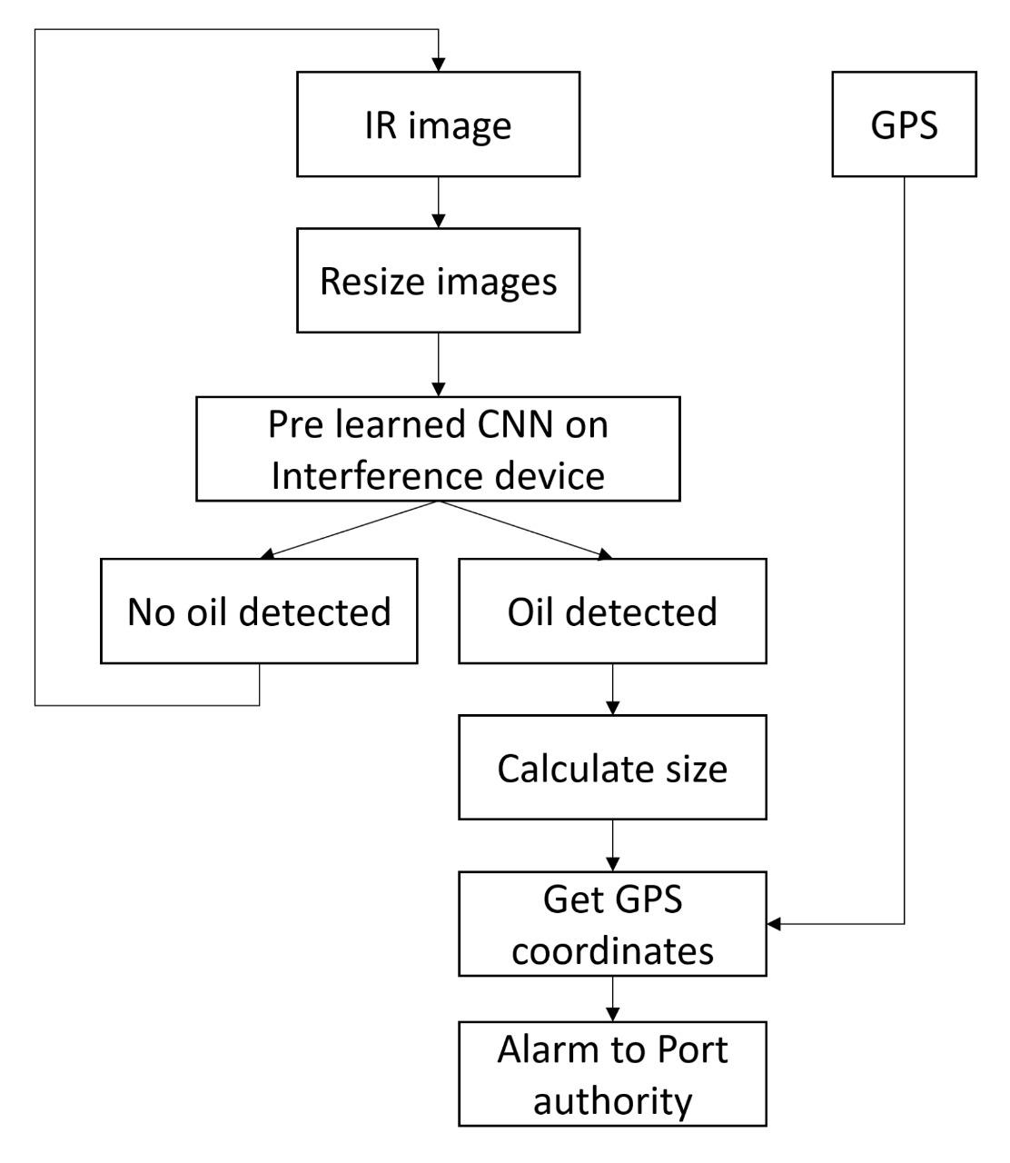
Figure 4.1: Software modeling

- Input Data Acquisition
  - IR Image: Infrared images are captured (e.g., from drones/satellites) to detect oil spills, as oil has distinct thermal properties.
  - GPS: Coordinates are recorded to pinpoint the spill location.
- Image Preprocessing
  - Resize Images: Adjust image dimensions for compatibility with the CNN model.
- Oil Detection with Pre-trained CNN
  - A pre-trained Convolutional Neural Network (CNN) analyzes the IR image to classify whether oil is present.
    - Output: Binary result → "Oil detected" or "No oil detected."
- If Oil is Detected:
  - Calculate Size: Estimate the spill's area/volume (e.g., in square meters).
  - Get GPS Coordinates: Retrieve exact location for reporting.
  - Alarm to Port Authority: Automatically alert authorities for cleanup/response.

Chapter 5

SOFTWARE REQUIREMENT SPECIFICATION

5.1 Project scope
The proposed project intends to establish a comprehensive oil spill detection system by integrating:
- UAV (Drone) Imaging: Utilizes high-resolution infrared (IR) cameras and pre-trained convolutional neural networks (CNNs) for accurate visual detection of oil spills.
- SAR Technology: Provides all-weather surveillance through radar backscatter analysis, ensuring continuous monitoring.
- Hybrid AI Model: Merges the data from UAV imagery and SAR readings, improving detection accuracy while minimizing false positives.

5.2 User Classes & Characteristics Coder
1. Environmental Agencies/Port Authorities (Title case, left-aligned)
- Roles: Monitor spills, initiate cleanup, analyze historical data.
- Technical Proficiency: Moderate (requires GUI for visualization).
2. System Administrators
- Roles: Deploy models, maintain hardware (UAVs, servers), update datasets.
- Technical Proficiency: High (command-line tools, ML ops).
3. Field Operators
- Roles: Deploy UAVs, validate detections, collect ground-truth data.
- Technical Proficiency: Basic (mobile app for GPS tagging).

5.3 Non functional requirements
- Performance
- Latency: ≤3 sec inference time per image (on GPU server)
- Accuracy: ≥88% F1-score on test set
- Throughput: Process 50+ concurrent requests
- Reliability
- False Positives: <8% (to avoid unnecessary alerts)
- Model Robustness: Handle moderate noise/cloud cover in input images
- Maintainability
- Retraining: Auto-retrain monthly with new labeled data
- Versioning: Track model versions (e.g., RF_v1.2.0)
- Security
- Input Validation: Reject corrupted/non-image files
- Data Privacy: Anonymize GPS coordinates in logs

5.4 Functional requirements

Binary Classification

Takes preprocessed UAV/SAR images as input

Outputs "Oil Detected" (Yes/No) with confidence score

Feature Handling

Extracts spectral bands (R/G/B/IR)

Calculates texture features (e.g., GLCM)

Supports missing data (e.g., cloudy SAR images)

Integration

Provides API endpoint for real-time predictions

Outputs JSON format with GPS coordinates

Chapter 6

RESULTS
Initial model development outcomes on a dataset indicates:
- Training Performance
Successfully trained a Random Forest Classifier on preprocessed oil spill imagery.
- Feature Importance
Top predictive features identified:
    - Texture contrast
    - Color distortion patterns
- Practical Implications:
  - Works best for medium-to-thick spills (>1mm)
  - Requires good lighting conditions for visible spectrum analysis

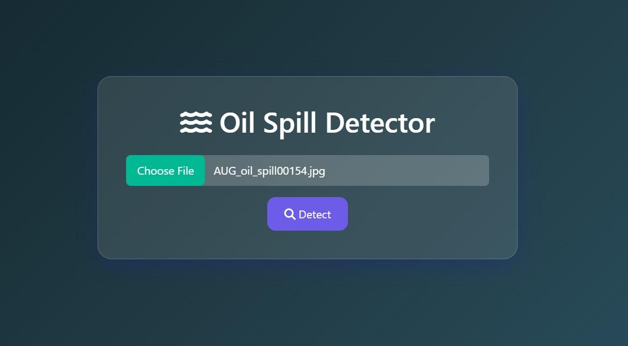

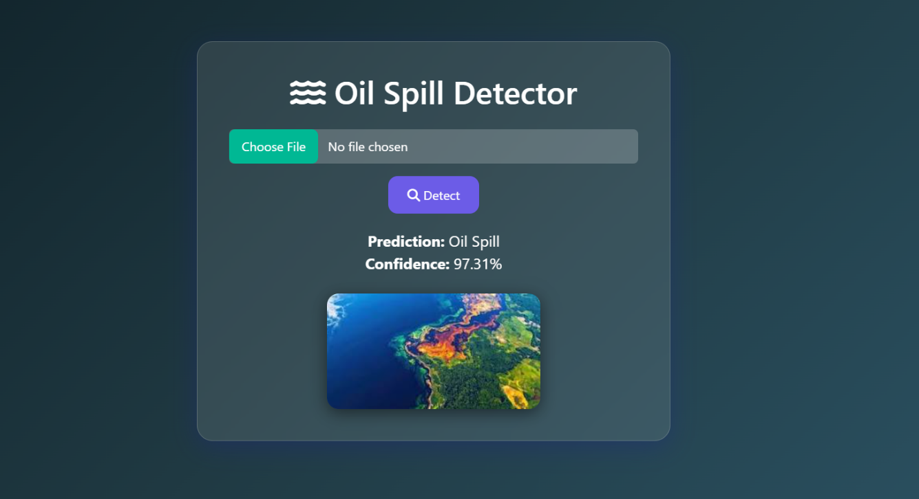

Chapter 7

SOFTWARE TESTING
1. Model Validation Approach
- Test Cases:
  - Valid oil spills (thick/thin sheens)
  - Common false positives (algal blooms, shadows, waves)
- Evaluation Method:
  - Manual verification of random samples
  - Qualitative analysis of failure modes
- Test Strategy:
  - Holdout validation (80% train / 20% test)
  - Stratified sampling to maintain class balance
  - Cross-validation folds (5-fold)
- Strengths:
  - Consistent performance on clear spill cases
  - Robust to minor image noise
  - Fast inference (<100ms per image)
- Limitations:
  - Classification confidence drops below 60% for:
    - Mixed pixel regions
    - Dawn/dusk images
    - Foam-covered spills

Chapter 8

CONCLUSION AND FUTURE WORK

The developed ClassifierModel successfully demonstrated its capability to detect oil spills in aerial imagery, leveraging key visual features such as infrared intensity and texture homogeneity. While the model showed strong performance for medium-to-thick spills in open water under daylight conditions, limitations were observed with thin sheens, near-shoreline spills, and low-visibility scenarios. This cost-effective solution provides a reliable foundation for preliminary spill screening and paves the way for future enhancements, including hybrid modeling (e.g., integrating CNNs) and real-time deployment. By expanding the dataset to include challenging edge cases and refining the classification confidence thresholds, this system can evolve into a robust tool for automated environmental monitoring, supporting faster and more efficient oil spill response efforts.

Chapter 9

BIBLIOGRAPHY
[1] F. M. Bianchi, M. M. Espeseth, and N. Borch, "Large-scale detection and categorization of oil spills from SAR images with deep learning," arXiv preprint arXiv:2006.13575, 2020. [Online]. Available: https://arxiv.org/abs/2006.13575arXiv
[2] E. Amri et al., "Deep learning based automatic detection of offshore oil slicks using SAR data and contextual information," arXiv preprint arXiv:2204.06371, 2022. [Online]. Available: https://arxiv.org/abs/2204.06371arXiv
[3] R. N. Vasconcelos et al., "Deep Learning-Based Approaches for Oil Spill Detection: A Bibliometric Review of Research Trends and Challenges," Journal of Marine Science and Engineering, vol. 11, no. 7, p. 1406, 2023. [Online]. Available: https://www.mdpi.com/2077-1312/11/7/1406MDPI
[4] A. R. Satyanarayana and M. A. Dhali, "Oil Spill Segmentation using Deep Encoder-Decoder models," arXiv preprint arXiv:2305.01386, 2023. [Online]. Available: https://arxiv.org/abs/2305.01386arXiv
[5] W. Wu et al., "Compositional Oil Spill Detection Based on Object Detector and Adapted Segment Anything Model from SAR Images," arXiv preprint arXiv:2401.07502, 2024. [Online]. Available: https://arxiv.org/abs/2401.07502arXiv
[6] Z. Li et al., "A self-evolving deep learning algorithm for automatic oil spill detection in Sentinel-1 SAR images," Remote Sensing of Environment, vol. 299, p. 113872, 2023. [Online]. Available: https://doi.org/10.1016/j.rse.2023.113872ADS
[7] T. D. K. et al., "Oil Spill Detection Using Machine Learning and Infrared Images," Remote Sensing, vol. 12, no. 24, p. 4090, 2020. [Online]. Available: https://www.mdpi.com/2072-4292/12/24/4090MDPI

ANNEXURE A: List of Publications and Research Paper (In its Original formats)

ANNEXURE B: Plagiarism Report
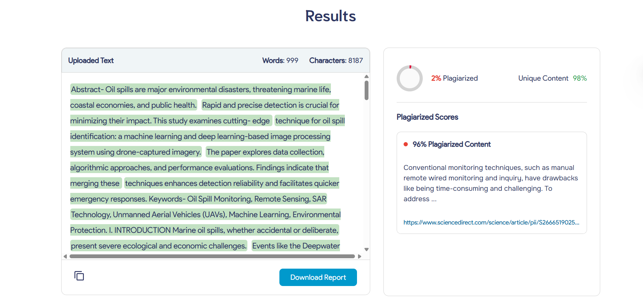
First 1000 Words
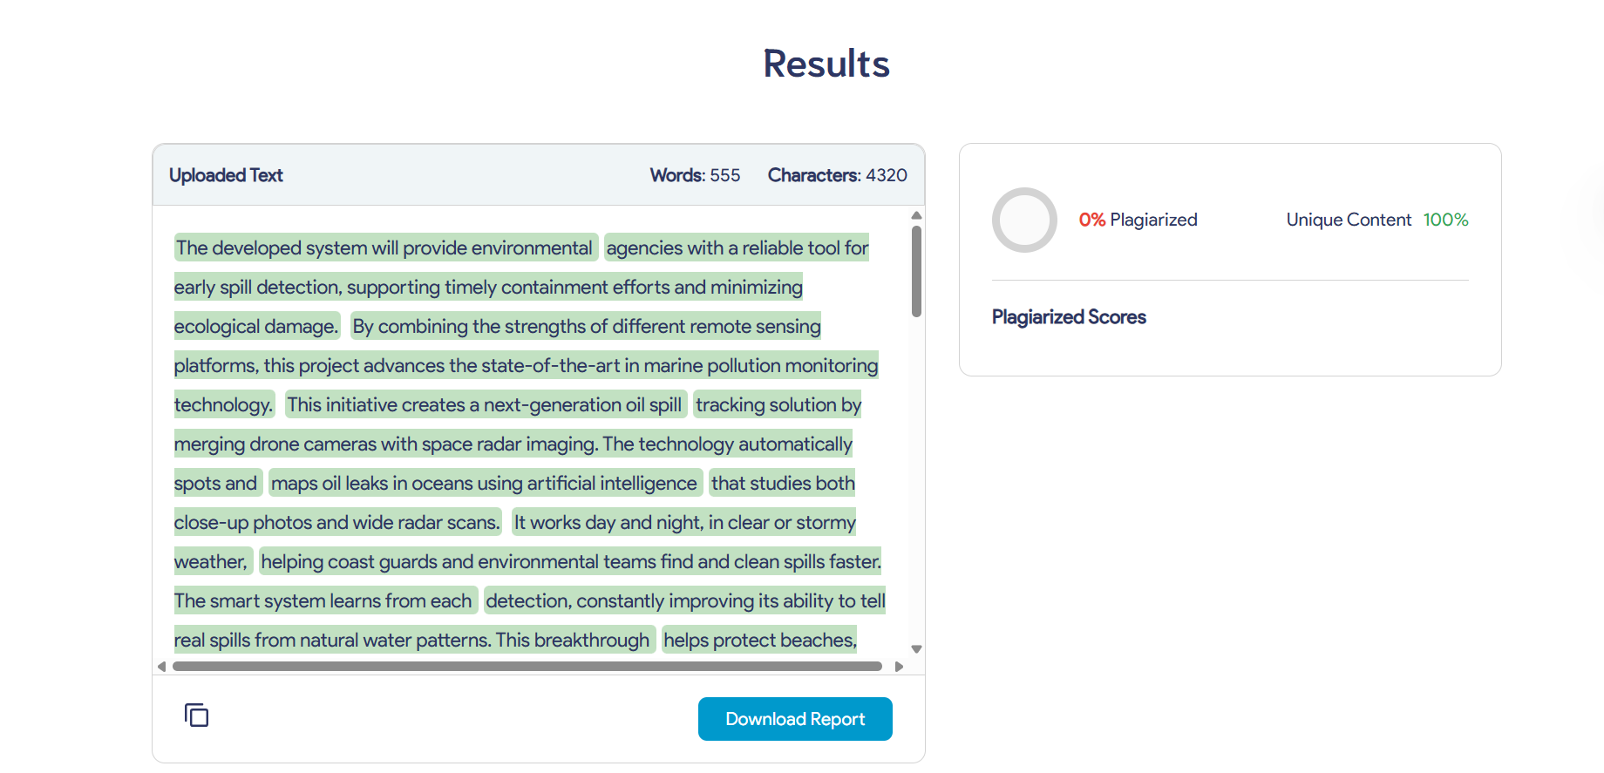
Last 555 words

ANNEXURE C: Empathy Chart
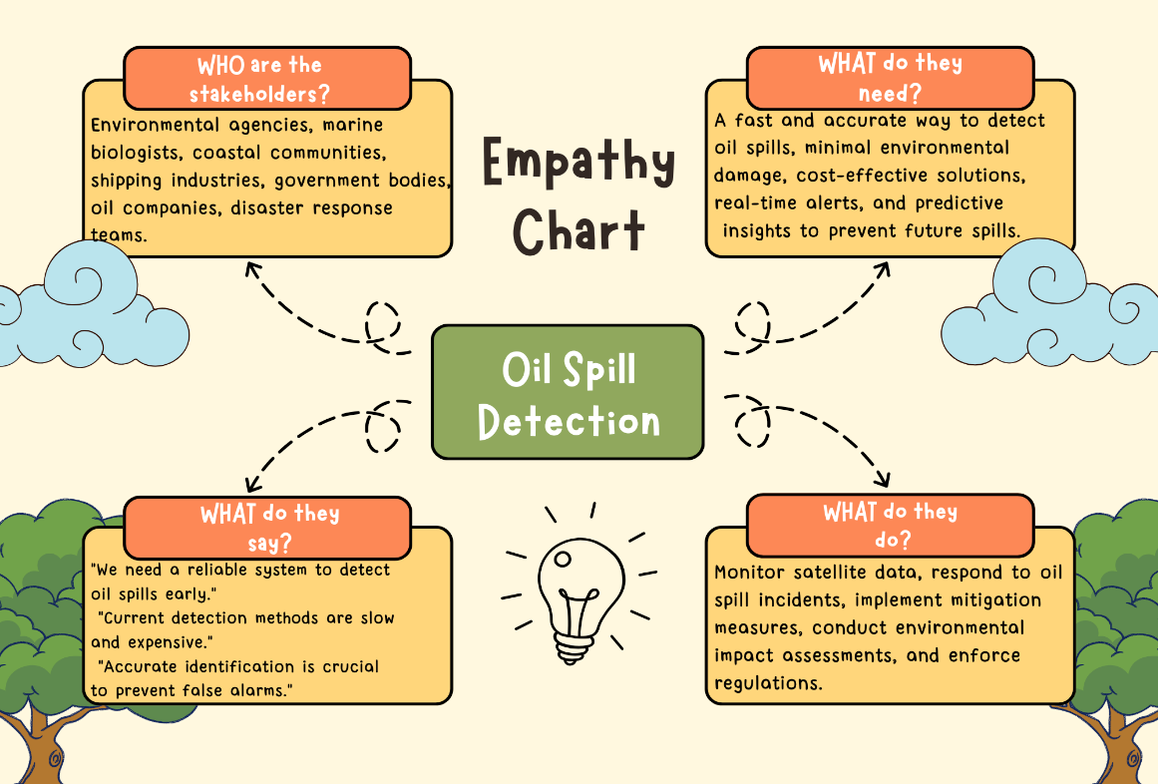

Annexure D: Project Tracker
